Chapter 13, Problem 71.

In the autotransformer circuit in Fig. 13.134, show that

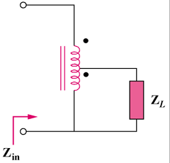

Figure 13.134
For Prob. 13.71.

